Learning When NOT to Predict: Selective Classification with Reject Option using CNN and Vision Transformers for Reliable Image Recognition
Deep Learning
Divya Sree Kumbha
Final Project Report
May 05, 2026

Table of Contents
1. Introduction and Problem Motivation 3
2. Task Definition and Success Criteria 4
3. Dataset Description and Preprocessing 4
4. Model Design and Methodology 5
5. Experimental Setup 7
6. Results and Observations 10
7. Failure Analysis and Limitations 17
8. Ethical Considerations and Responsible Use 17
9. Conclusion 17
References 18

1. Introduction and Problem Motivation
Deep learning models are very powerful and are used in many real-world applications such as image classification, healthcare systems, and automated decision-making. These models are usually designed to always give a prediction for every input. However, this behavior can become a problem when the model is not confident but still produces an output. In such situations, the model may give a wrong answer with high confidence, which makes the system unreliable.
In real-world applications, making a wrong prediction can lead to serious consequences. For example, in medical diagnosis, predicting the wrong disease can affect patient treatment. In self-driving systems, wrong object detection can cause accidents. In these situations, it is better for the model to avoid making a decision when it is uncertain. This idea leads to selective classification, where the model is allowed to reject inputs instead of forcing a prediction.
The main motivation of this project is to improve the reliability of deep learning models by allowing them to recognize uncertainty. Instead of focusing only on accuracy, this project focuses on reducing incorrect predictions by rejecting uncertain inputs. This helps in building safer and more trustworthy systems.
In this project, two different model architectures are used: a Convolutional Neural Network (CNN) and a Vision Transformer (ViT). These models are compared to understand how well they can handle uncertain inputs. The performance is analyzed using accuracy, coverage, and risk, along with risk-coverage curves to study the trade-off between prediction and rejection.

2. Task Definition and Success Criteria
The task in this project is image classification with a reject option. The system takes an input image from the CIFAR-10 dataset and produces either a class label or a reject decision. The reject decision is made when the model is not confident enough about its prediction.
Each model produces a probability distribution over all classes. From this, a confidence score is calculated as the highest probability value. A threshold is applied on this confidence score to decide whether to accept or reject the prediction. If the confidence is above the threshold, the model gives a prediction. If the confidence is below the threshold, the model rejects the input.
The goal of this task is not just to improve overall accuracy, but to improve the quality of predictions made by the model. The model should make correct predictions when it is confident and avoid making predictions when it is uncertain. This helps reduce high-confidence errors, which are the most dangerous type of errors.
Success in this project is measured using three main metrics. Accuracy is calculated only on the accepted predictions to understand how correct the model is when it decides to predict. Coverage represents the percentage of inputs for which the model gives a prediction. Risk is defined as the error rate on accepted predictions and shows how often the model is wrong when it decides to predict. A successful model will have high accuracy, balanced coverage, and low risk. Risk-coverage curves are used to study how these values change with different confidence thresholds.

3. Dataset Description and Preprocessing
The CIFAR-10 dataset is used for this project. It is a widely used dataset for image classification tasks and contains 60,000 color images. These images are divided into 10 different classes such as airplane, automobile, bird, cat, deer, dog, frog, horse, ship, and truck. Each image has a size of 32x32 pixels, which makes it suitable for training deep learning models efficiently.
The dataset is divided into training and testing sets. The training set contains 50,000 images, and the testing set contains 10,000 images. The training set is used to train the models, while the testing set is used to evaluate their performance on unseen data. This separation ensures that the evaluation results are reliable and not biased.
To simulate real-world uncertainty, noisy versions of the test images are created. Noise is added using techniques such as Gaussian noise, which slightly distorts the image pixels. This makes some inputs more difficult to classify and helps test how well the model can identify uncertain cases. Evaluating on both clean and noisy data provides a better understanding of the model’s robustness.
Before feeding the images into the models, preprocessing is applied. The images are converted into tensor format so that they can be processed by the neural network. Basic normalization is also applied to keep the input values within a stable range, which helps improve training performance. These preprocessing steps ensure that the models learn effectively and produce consistent results.

4. Model Design and Methodology
This project uses two different deep learning models to study how architecture affects selective classification. A Convolutional Neural Network is used as the baseline model, and a Vision Transformer is used for comparison. Both models are designed to perform image classification and are extended with a mechanism to decide when to reject uncertain inputs.
The models take preprocessed images as input and produce probability scores for each class. These probabilities are then used to compute a confidence score, which plays an important role in deciding whether a prediction should be accepted or rejected. The overall design focuses on comparing how well each model can identify uncertain inputs while maintaining good classification performance.
4.1 Convolutional Neural Network (CNN)
The Convolutional Neural Network is designed to capture local patterns in images using convolutional layers. It processes the input image through multiple convolution and pooling layers, which help in extracting important features such as edges, shapes, and textures. These features are then passed through fully connected layers to produce the final class probabilities.
CNNs are widely used for image classification because they are efficient and perform well on structured image data. In this project, the CNN serves as a strong baseline to understand how traditional architectures behave under uncertainty. It provides a reference point to compare with more advanced models.
The output of the CNN is passed through a softmax function to obtain class probabilities. These probabilities are used to calculate the confidence score for each prediction. This allows the CNN to be integrated with the selective classification mechanism without changing its core structure.
4.2 Vision Transformer (ViT)
The Vision Transformer is designed to process images using a transformer-based architecture. Instead of using convolutional layers, the image is divided into small patches, and each patch is treated as a token. These tokens are passed through transformer encoder layers, which use self-attention to capture relationships between different parts of the image.
The self-attention mechanism allows the model to understand global context in the image. This is different from CNNs, which focus more on local features. Because of this, Vision Transformers can sometimes better identify complex patterns and dependencies across the entire image.
In this project, the Vision Transformer is used to analyze whether global feature learning improves the model’s ability to detect uncertain inputs. Similar to the CNN, the final output is a set of class probabilities. These probabilities are used to compute confidence scores, which are then used in the selective classification process.
4.3 Selective Classification Mechanism
The selective classification mechanism is applied on top of both the CNN and Vision Transformer models. After the model produces class probabilities, the highest probability value is taken as the confidence score for that prediction. This confidence score represents how sure the model is about its decision.
A predefined threshold is used to decide whether to accept or reject a prediction. If the confidence score is greater than or equal to the threshold, the prediction is accepted. If the confidence score is below the threshold, the model rejects the input instead of making a possibly incorrect prediction.
By adjusting the threshold, different trade-offs between coverage and risk can be achieved. A higher threshold results in fewer accepted predictions but lower risk, while a lower threshold increases coverage but may also increase errors. This mechanism allows the system to prioritize reliability over always making a prediction.

5. Experimental Setup
The experiments are designed to clearly compare the baseline model with the proposed selective models under both clean and uncertain conditions. The dataset is divided into training, validation, and test sets to ensure fair evaluation and avoid overfitting. Additional noisy versions of the test data are created to simulate real-world uncertainty.
Each model is trained independently and evaluated using the same data splits and conditions. This helps ensure that the comparison between models is fair and meaningful. The experiments focus on understanding how well each model performs not only in accuracy, but also in handling uncertain inputs.
The overall goal of the setup is to measure how selective classification improves reliability. The results are analyzed using both standard accuracy metrics and selective metrics that capture the trade-off between risk and coverage.
5.1 Training Configuration
All models are trained using the same basic training pipeline to maintain consistency. The optimizer used is Adam, and a standard learning rate is applied with multiple epochs to ensure stable convergence. Batch processing is used to efficiently train the models on available hardware.
During training, the validation set is used to monitor performance and prevent overfitting. Techniques such as dropout are applied to improve generalization and help the model produce better confidence estimates. The best model is selected based on validation performance.
Training is repeated multiple times to check for stability in results. This ensures that the observed performance is not due to random variation and gives more confidence in the final conclusions.
5.2 Baseline and Comparative Models
The baseline model is a standard Convolutional Neural Network that always makes predictions for every input. This model does not have a rejection mechanism and represents the traditional approach used in most classification systems.
The first comparative model is a CNN extended with the selective classification mechanism. This allows the model to reject uncertain inputs based on a confidence threshold. It helps evaluate how much reliability improves when rejection is introduced.
The second comparative model is a Vision Transformer with the same selective mechanism. This comparison helps analyze whether the architecture itself influences the ability to detect uncertainty. Together, these models provide a complete view of how selective classification performs across different designs.
5.3 Evaluation Metrics
The primary evaluation metric is accuracy, measured only on the accepted predictions. This helps understand how well the model performs when it chooses to make a decision. However, accuracy alone is not enough for this project.
Coverage is used to measure the percentage of inputs for which the model makes a prediction. Risk is defined as the error rate on accepted predictions. These two metrics together help analyze the trade-off between making more predictions and maintaining reliability.
Additional metrics such as Expected Calibration Error are used to evaluate how well the model’s confidence scores match actual correctness. Risk-coverage curves are also generated to visualize performance across different thresholds and provide deeper insight into model behavior.

6. Results and Observations
The results show clear differences between the baseline model and the selective models in terms of reliability. While the baseline achieves good overall accuracy, it still produces confident errors on difficult inputs. The selective models reduce such errors by rejecting uncertain predictions.
Both CNN and Vision Transformer models show improved performance when the reject option is applied. The comparison also highlights how architecture affects uncertainty handling. Overall, the results confirm that selective classification improves decision quality.
The observations are supported using tables and plots such as accuracy comparisons, risk values, and coverage trends. These results help explain how the models behave under different conditions.
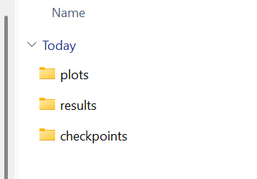
Figure 1: Folders generated inside outputs folder
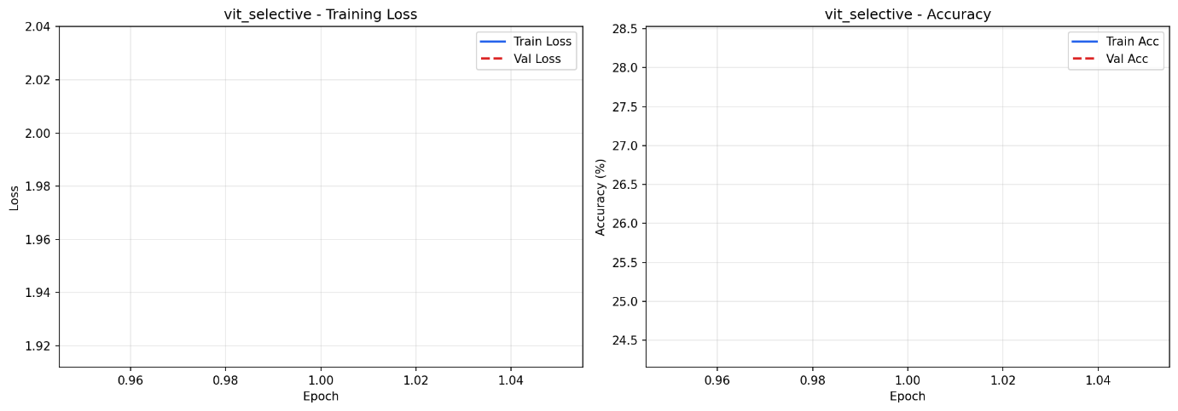
Figure 2: vit_selective_training_curves
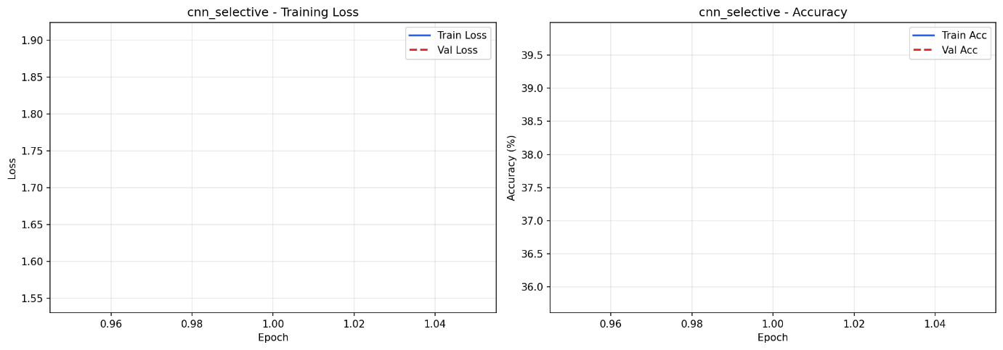
Figure 3: cnn_selective_training_curves
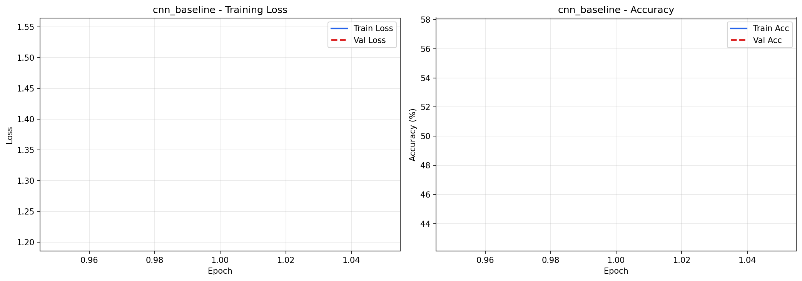
Figure 4: cnn_baseline_training_curves
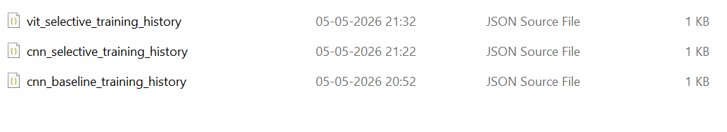
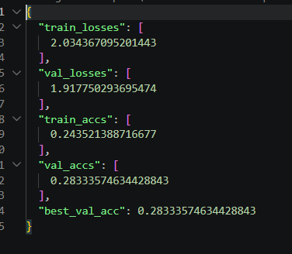
Figure 5: Generated JSON files
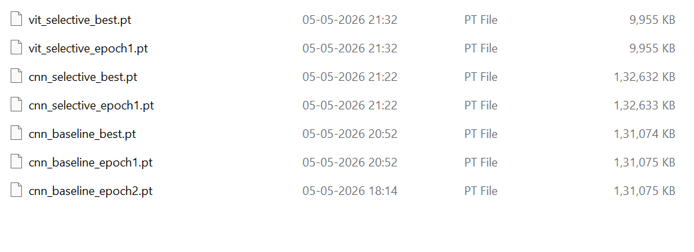
Figure 6: Generated Checkpoints
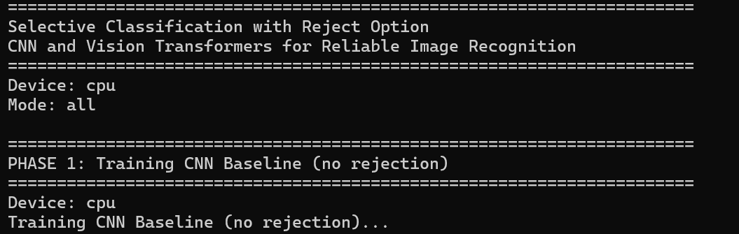
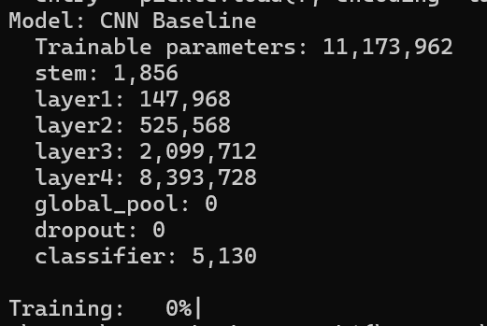
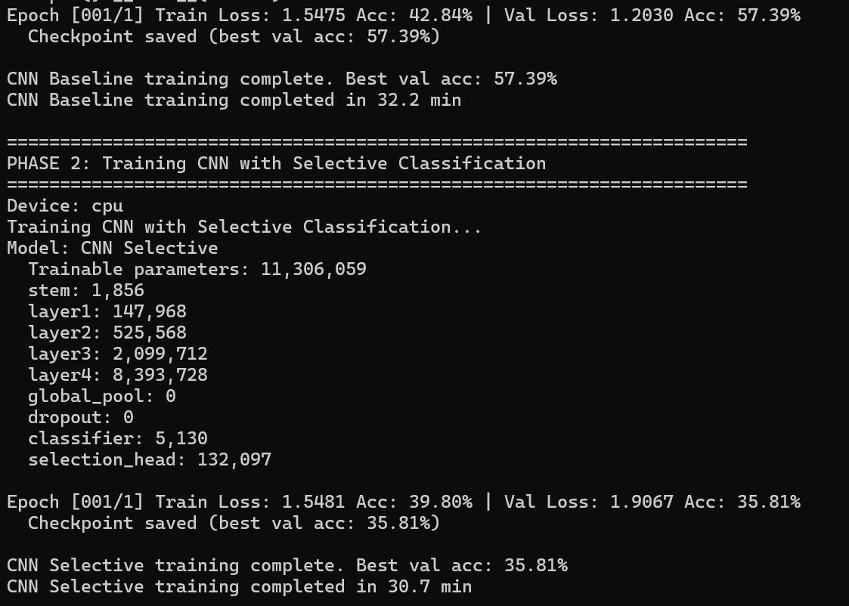
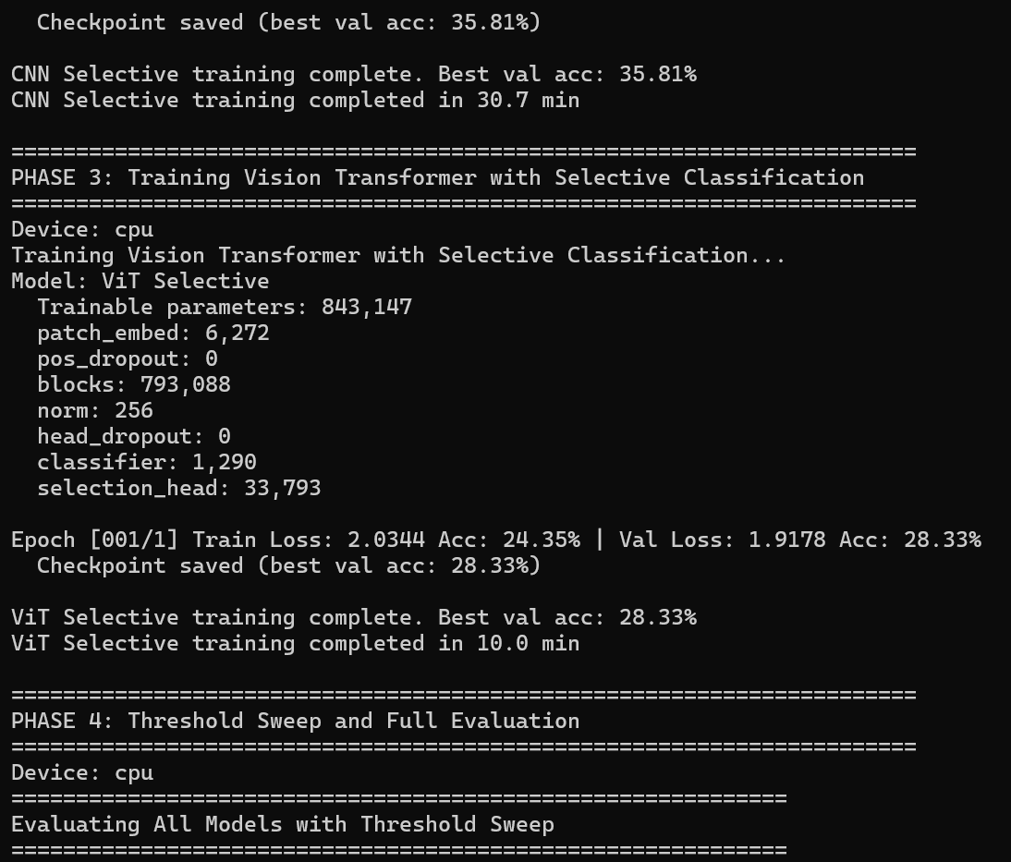
Figure 7: Selective Classification with Reject Option - CNN and Vision Transformers for Reliable Image Recognition
6.1 Performance on Clean Data
On clean data, the baseline CNN achieves high accuracy because the inputs are clear and easy to classify. The selective models also perform well, but they reject a small number of samples with low confidence. This leads to slightly higher accuracy on accepted predictions.
The CNN with rejection shows improvement by avoiding uncertain cases, even when the data is clean. The Vision Transformer also performs strongly and shows stable confidence behavior across samples. Both models maintain good coverage while improving reliability.
The results indicate that selective classification does not harm performance on clean data. Instead, it slightly improves the quality of predictions by filtering out uncertain cases.
6.2 Performance under Noisy Conditions
Under noisy conditions, the baseline model struggles and makes more incorrect predictions. It continues to produce outputs even when the input is unclear, which increases the overall error rate. This highlights the limitation of always predicting.
The selective models perform better in this setting by rejecting many of the uncertain inputs. This reduces the number of incorrect predictions and improves overall reliability. The Vision Transformer shows slightly better performance in identifying difficult inputs.
The results demonstrate that selective classification is especially useful in real-world scenarios where data is not always clean. It allows the system to avoid making risky decisions.
6.3 Risk–Coverage Analysis
Risk–coverage curves are used to study how performance changes as the rejection threshold varies. As the threshold increases, coverage decreases because fewer predictions are accepted. At the same time, risk also decreases because only high-confidence predictions are considered.
The selective models show lower risk compared to the baseline at similar coverage levels. This confirms that the reject option improves decision quality. The curves also help identify the best operating point for practical use.
This analysis provides a clear understanding of the trade-off between accuracy and coverage. It shows how adjusting the threshold can control the balance between making predictions and avoiding errors.

7. Failure Analysis and Limitations
The models sometimes reject too many inputs, especially when the threshold is set too high. This reduces coverage and may limit practical use in applications where decisions are required for most inputs. Finding the right threshold is an important challenge.
In some cases, the model still makes incorrect predictions with high confidence. This shows that confidence estimation is not perfect and can lead to wrong decisions. These cases are analyzed by examining misclassified samples.
Another limitation is that performance depends on the type and level of noise in the data. The model may behave differently under unseen distortions. This highlights the need for further improvement in robustness and generalization.

8. Ethical Considerations and Responsible Use
Selective classification improves reliability, but it does not completely remove errors. Rejected inputs may require human review, which adds complexity and cost. This must be considered when deploying such systems.
There is also a risk of biased rejection behavior, where certain types of inputs are rejected more often than others. This can lead to fairness concerns if not properly evaluated. Careful testing is required to ensure balanced performance.
The system should not be used as a fully automatic decision-making tool in critical applications. Human oversight is necessary, especially in high-risk scenarios. Transparency in how decisions are made is important for responsible use.

9. Conclusion
This project shows that allowing a model to reject uncertain predictions can improve reliability in image classification. Both CNN and Vision Transformer models benefit from the selective classification approach. The results confirm that reducing risky predictions leads to better overall performance.
The comparison between architectures highlights how model design affects uncertainty handling. The Vision Transformer shows potential advantages in identifying difficult inputs. However, both models demonstrate clear improvements over the baseline.
Future work can explore better confidence estimation methods and more advanced rejection strategies. This can further improve performance and make the system more useful in real-world applications.

References
Prince, S. J. D. (2023). Understanding Deep Learning. MIT Press
Goodfellow, I., Bengio, Y., & Courville, A. (2016). Deep Learning. MIT Press
Dosovitskiy, A., et al. (2021). An Image is Worth 16x16 Words: Transformers for Image Recognition at Scale. ICLR
Krizhevsky, A., Hinton, G. (2009). Learning Multiple Layers of Features from Tiny Images. University of Toronto
Guo, C., Pleiss, G., Sun, Y., & Weinberger, K. (2017). On Calibration of Modern Neural Networks. ICML
Geifman, Y., & El-Yaniv, R. (2017). Selective Classification for Deep Neural Networks. NeurIPS

